GENERAL DESCRIPTION

UHFReader28 is a high performance UHF RFID fixed reader. It is designed upon fully self-intellectual property. Based on proprietory efficient digital signal processing algorithm, it supports fast tag read/write operation with high identification rate. It can be widely applied in many RFID application systems such as logistics, access control, anti-counterfeit and industrial production process control system.

FEATURES
- Self-intellectual property;
- Support ISO18000-6C(EPC C1G2) , ISO18000-6B protocol tag;
- 902~928MHz frequency band(frequency customization optional);
- FHSS or Fix Frequency transmission;
- RF output power up to 30dbm(adjustable);
- 4 TNC antenna port;
- Support auto-running, answer and trigger work mode;
- Support EPC and TID inventory;
- Low power dissipation with single +9 DC power supply;
- Support RS232, RS485, TCPIP with other interface optional;
- Built-in LED, Buzzer, GPIO and Relay;
- High reliability design.
CHARACTERISTICS
- Absolute Maximum Rating
ITEM | SYMBOL | VALUE | UNIT
Power Supply | VCC | 16 | V
Operating Temp. | T_{OPR} | -10~+55 | ℃
Storage Temp. | T_{STR} | -20~+75 | ℃
- Electrical and Mechanical Specification
Under T_{A}＝25℃，VCC＝+9V unless specified
ITEM | SYMBOL | MIN | TYP | MAX | UNIT
Power Supply | VCC | 8 | 9 | 12 | V
Current Dissipation | I_{C} |  | 600 | 1500 | mA
Frequency | F_{REQ} | 902 |  | 928 | MHz
Size | Size |  | 160x186x50 |  | mm

INTERFACE
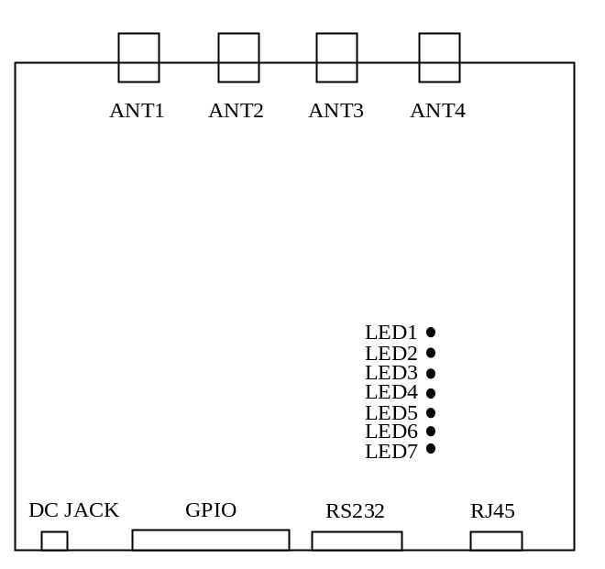
1．Power (DC JACK)
No. | Symbol | Comment
Central | PWR | +9VDC
Outer | GND | Ground
2．GPIO （DB15 Female）
No. | Symbol | Comment
1 | Output1 | General Output1
2 | Output2 | General Output2
3 | Output3 | General Output3
4 | Output4 | General Output4
5 | Output5 | General Output5
6 | Output6 | General Output6
7 | Output7 | General Output7
8 | Output8 | General Output8
9 | TGIN | Trigger input with internal pull-up to 5V through a 10k resistor
10 | R+ | R+ of RS485
11 | R- | R- of RS485
12 | GND | Signal Ground
13 | NO | Normal-Open terminal of internal relay
14 | NC | Normal-Close terminal of internal relay
15 | CM | Common terminal of internal relay

3．Serial communication port RS232 （DB9 Male）
No. | Symbol | Comment
1 | nc | Reserved
2 | TXD | General Output2
3 | RXD | General Output3
4 | nc | Reserved
5 | GND | Ground
6 | nc | Reserved
7 | nc | Reserved
8 | nc | Reserved
9 | nc | Reserved
4．TCPIP network (RJ45)
5．TNC antenna port ANT1~ANT4
6．LED indicator LED1~LED7
No. | Symbol | Comment
1 | LED1 | Antenna 1 active indicator
2 | LED2 | Antenna 2 active indicator
3 | LED3 | Antenna 3 active indicator
4 | LED4 | Antenna 4 active indicator
5 | LED5 | Tag-detected indicator
6 | LED6 | Command-executing indicator
7 | LED7 | Power-on indicator

